Deep learning
Deep learning is a subset of machine learning that use multilayered neural networks, to automatically learn patterns from data.
Ml vs dl
Machine Learning (ML) and Deep Learning (DL) are subsets of Artificial Intelligence (AI), but they differ in approach and complexity. ML uses algorithms that learn from structured data and often require manual feature engineering. It works well with smaller datasets and tasks like classification and prediction.
Deep Learning (DL) is a subset of ML that uses multi-layer neural networks to automatically learn features from large amounts of unstructured data such as images, audio, and text. DL is powerful for complex tasks but requires more computational resources and is harder to interpret.

A Neural Network is a core concept in machine learning and deep learning, inspired by how the human brain works.
What is a neuron?
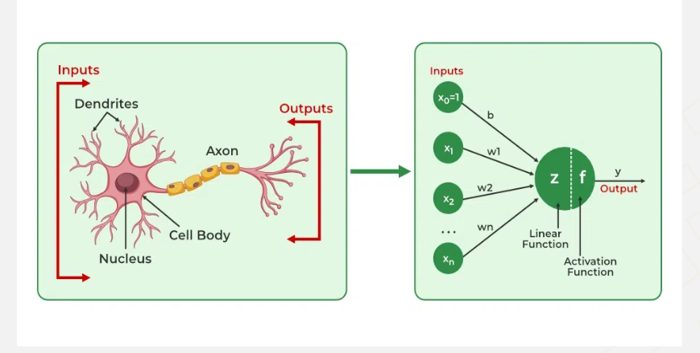
A neuron is a mathematical function that mimics, in a simplified way, the behavior of a biological neuron. It’s a fundamental unit of artificial neural networks (ANNs) and is responsible for processing inputs and producing an output.
Neural networks are machine learning models that mimic the complex functions of the human brain.
These models consist of interconnected nodes or neurons that process data, learn patterns and enable tasks such as pattern recognition and decision-making.
NN Components
- Neurons: The basic units that receive inputs, each neuron is governed by a threshold and an activation function.
- Connections: Links between neurons that carry information, regulated by weights and biases.
- Weights and Biases: These parameters determine the strength and influence of connections.
- Propagation Functions: Mechanisms that help process and transfer data across layers of neurons.
- Learning Rule: The method that adjusts weights and biases over time to improve accuracy.
Layers in Neural Network Architecture
- Input Layer: This is where the network receives its input data. Each input neuron in the layer corresponds to a feature in the input data.
- Hidden Layers: These layers perform most of the computational heavy lifting. A neural network can have one or multiple hidden layers. Each layer consists of units (neurons) that transform the inputs into something that the output layer can use.
- Output Layer: The final layer produces the output of the model. The format of these outputs varies depending on the specific task like classification, regression.
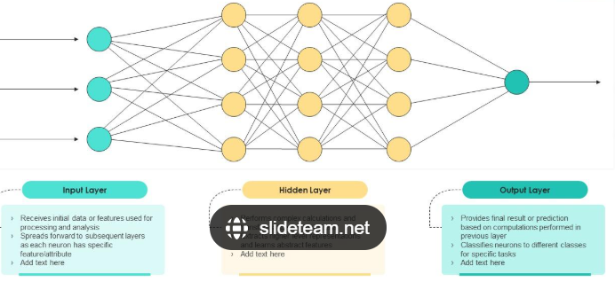

In a neural network, input data is passed through multiple layers, including one or more hidden layers. Each neuron in these hidden layers performs several operations, transforming the input into a usable output.

A perceptron is the simplest neural network.
It consists of:
- Inputs are features of the data
- Weights
- Bias
- Weighted sum
- Activation function
- Output Final decision of the neuron
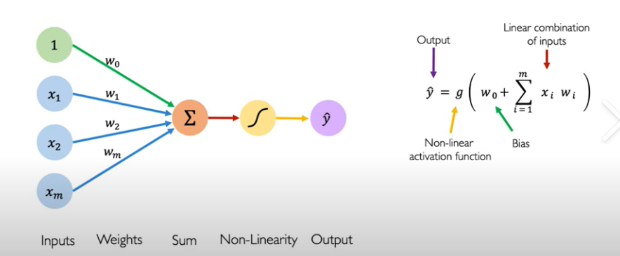

A weighted sum is a mathematical concept used to aggregate multiple values into a single representative value, taking into account the relative importance of each value.

Keras is an open-source deep learning API that runs on top of lower-level frameworks like TensorFlow, Theano, or CNTK. It allows you to build and train neural networks easily without dealing with all the low-level math and computations.

What is an Activation Function?
An activation function takes the weighted sum of inputs plus bias and transforms it into an output:
$$\text{Output}=f(∑w_{i}x_{i}+b)$$
Without activation functions, a neural network would behave like a simple linear model and could not learn complex patterns.

Forward Pass (Prediction)
1. Take inputs
2. Multiply by weights
3. Add bias
4. Apply activation function
5. Produce prediction

